The University of Winchester published its original Degree Outcomes Statement in July 2020. This current iteration of the Statement has been updated to include the most current classification data.

- Institutional Degree Classification Profile

- The percentage of first and upper second awards in 20-21 dropped 4% at the University from 79% to 75%. In comparison, the sector percentage of first and upper second awards in 20-21 increased by 1%, from 78% to 79%, with the proportion of firsts awarded increasing by 2%, from 33% to 35%.

- The overall University percentage of firsts and upper second awards is now 4% lower than the sector average (20-21).

Winchester | Sector
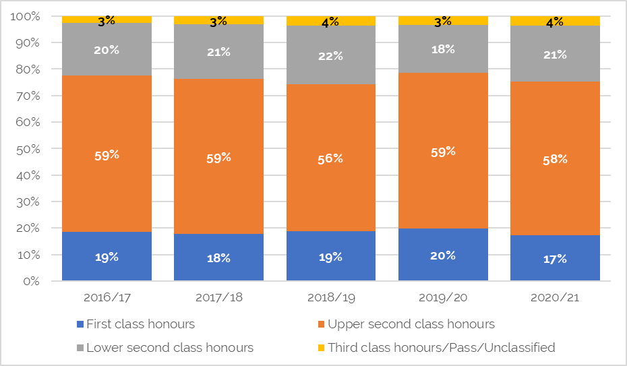 | 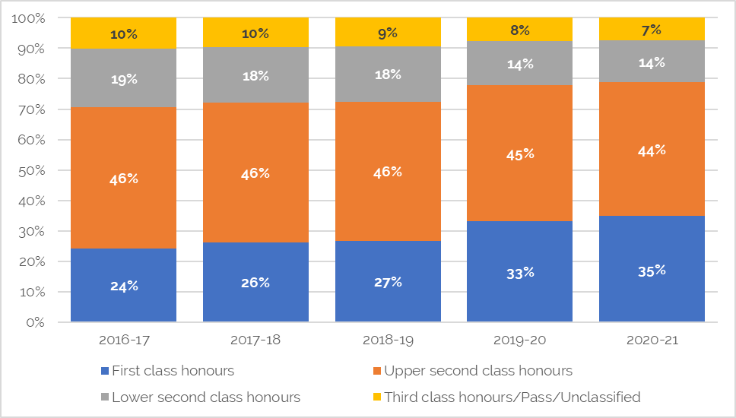

- In December 2021, the university’s Degree Outcomes Statement Standing group reviewed an analysis of the impact of the university’s no detriment policies (NDP) and upgrade rule on student attainment. The analysis concluded that the NDP had a lower impact on the University’s degree classifications compared with the Upgrade Rule. The Upgrade Rule led to an upwards effect of ~2.5% in the percentage of Good Honours, whereas the NDP’s corresponding effect in its two years of application (2019-20 and 2020-21) averaged a 1.5% upwards effect.
- As noted in section 4 below, the Upgrade Rule has been removed from the university's regulations and only applies to students who were studying in September 2018. The number of students to whom the rule applies is therefore diminishing and the effect of the upgrade rule on good honours was only 0.3% for 2020-21.
1.1 Sex
- Female students at the University of Winchester usually obtain a higher proportion of good degrees (first/upper second) than do males. The University’s outcomes mirror those shown across the sector. Numbers of ‘other sex’ students at Winchester do not meet accepted sector publication thresholds and therefore results are withheld to ensure that no individuals can be identified in the data.

Winchester – degree classification by sex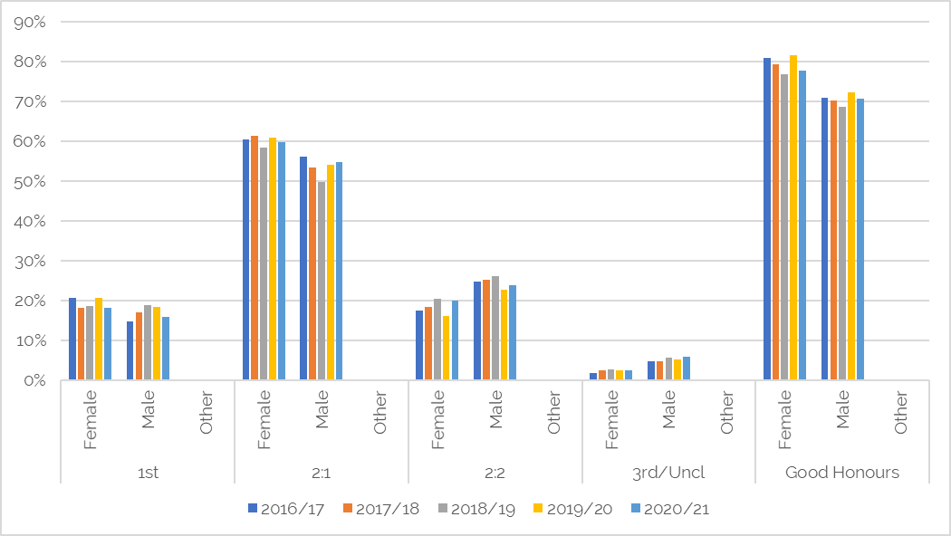
Sector – degree classification by sex
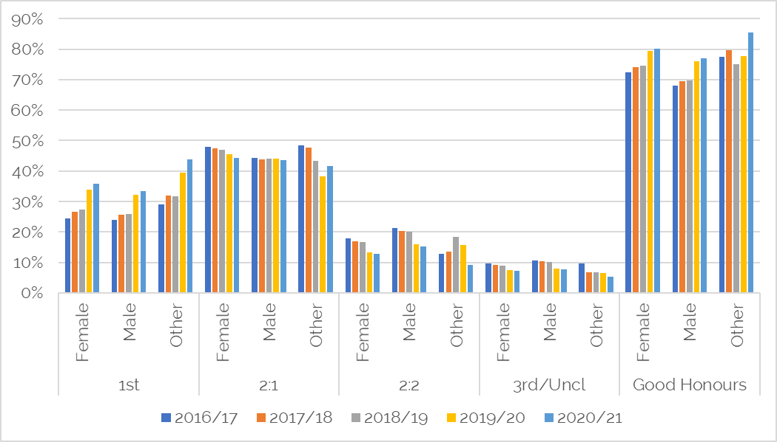

1.2 Subject differences

- There are fundamental differences at subject level across the sector with wide variations in the proportion of Good Honours. Elements of this variation in Good Honours is also reflected in the Winchester data.

- However, there are other variations in Good Honours that do not compare closely to sector averages for the same subject e.g., -28% difference Biological and sport sciences; -26% Geography, earth and environmental studies (natural sciences); and -18% Psychology.

1.3 Entry tariff

- Research relating to the distribution of awards indicates that at an aggregated level there is a strong positive correlation between average tariff of entrants and the final classification at an institutional level. i.e., students with higher prior attainment tend to gain a higher award. At an individual level it is not possible to disentangle all possible factors due to the complexity of the entry qualification and personal characteristics of each student.

Winchester - degree outcomes against average entry tariff
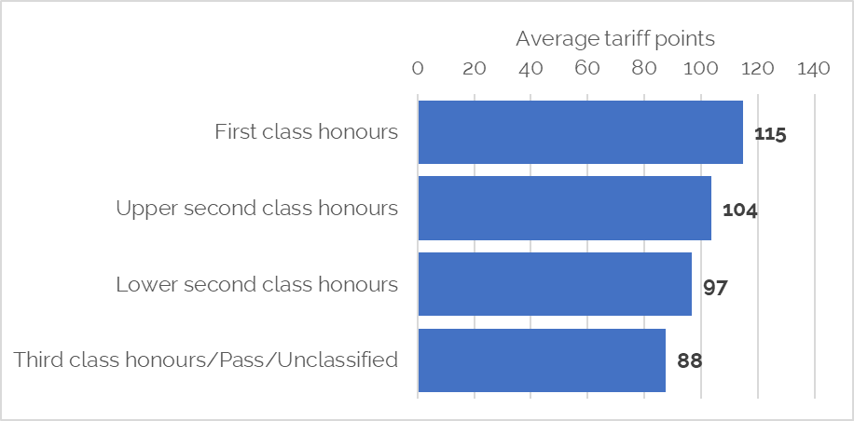

  - Students from Black, Asian and Minority Ethnic (BAME) Backgrounds

- The University continues to prioritise addressing the ethnicity gaps in degree outcomes as outlined in the current Access and Participation Plan. This includes taking a targeted approach to disaggregate the data via data insight projects and qualitative research into student experiences amongst different cohorts, embedding inclusive curriculum design, mentoring schemes and Black Asian and Minority Ethnic (BAME) Ambassador projects.
- In 2019/20, progress was being made in closing the awarding gaps, however the most recent Office for Student Data Dashboard reveals that the (BAME) awarding gap sits at 18 percentage points compared to 9 percentage points nationally. In 2020/21 60% of our BAME students attained a first or upper second-class degree (compared with the sector average 77%) compared to 77.6% of their white peers.
- Further disaggregated data has demonstrated that the gap is largest for Black students, where 55% of Black students obtained a first or upper second-class degree (compared with the sector average 69.3%), a percentage point gap of 25 percentage points with white students (compared with 17.4 percentage points nationally).
- However, we must be mindful that the data relates to small cohort sizes of 140 BAME students of which 40 identified as Black and 50 as Asian, when compared to 1560 White students. None of the awarding gap data for BAME students in 2020/21 has been found to be statistically significant. As such, we continue to explore trends and intersectional differences.
- Internal analysis has also identified that a larger proportion of BAME-UK domicile students arrived with lower tariff points, 62% of BAME students entered with under 120 tariff points (equivalent to BBB at A-level) compared to 51% of White students. Acknowledging, as per point 1.3., that there is a correlation between average entry tariff and degree classification, this can also be seen amongst the BAME student cohort. As such, the awarding gap is largest amongst those entering with the under 70 (below DDD) tariff points or over 160 (above A*A*A*).
- In 2022/23, the University will be piloting a new bursary programme with academic-coaching and career-mentoring for a cohort of BAME students on Health, Education and Social Work pathways.

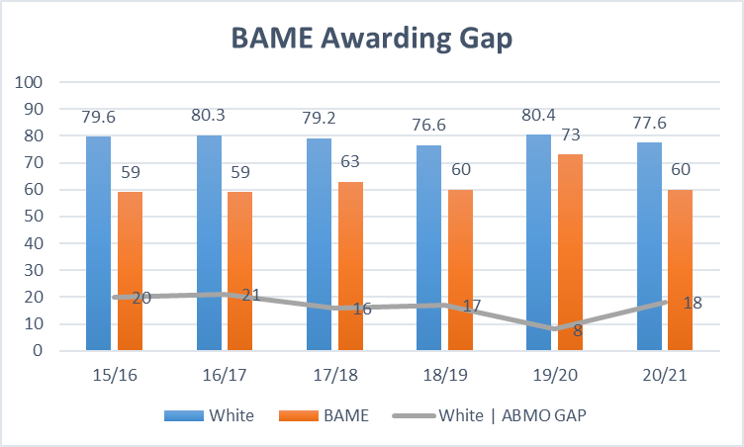
Tariff band upon entry | White |  | BAME |  | pp gap
 | n | % | n | % | %
<70 | 88 | 72.1% | 10 | 41.70% | 30.4%
70-120 | 498 | 75.6% | 37 | 62.7% | 12.9%
120-160 | 354 | 83.7% | 15 | 79.0% | 4.7%
>160 | 104 | 81.3% | 0 | 0.00% | 81.3%

1.5 Mature Students
- For the last 5 years, mature full-time first-degree students (aged 21 or over on entry) were more likely to attain a first or upper-second class degree than their younger peers (aged under 21 on entry). This trend is contrary to the consistent gaps found amongst mature students nationally.

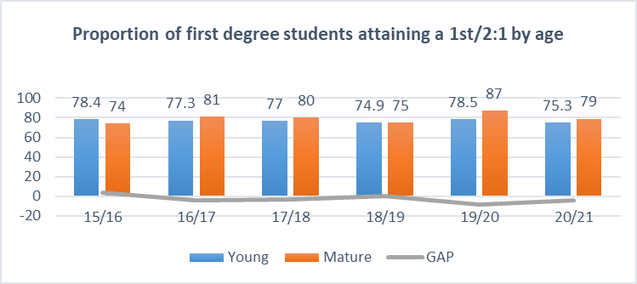

1.6 Students from the most deprived backgrounds
- The proportion of our full-time first-degree students achieving a first or upper second from the most deprived neighbourhoods in England (IMD Q1) increased from 61% in 2016/17 to 67% in 2020/21, resulting in the awarding gap between the most and least deprived students narrowing to 10 percentage points (IMD Q1:Q5). This compares to 14.8 percentage points nationally.
- A number of measures are being taken to continue narrowing the awarding gap for students from the most deprived neighbourhoods. These include developing a transition programme to enhance academic confidence and engagement with academic study skills support; being informed by learner analytics data to target individualised support; integrating Universal Design for Learning (UDL) measures within curriculum validation and design and developing more inclusive assessment measures where possible.
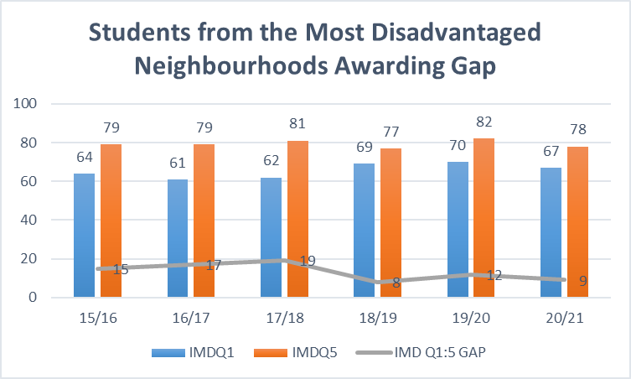

1.7 Students from low-participation neighbourhoods
- The proportion of our full-time first-degree students achieving a first or upper second from low participation neighbourhoods (POLAR 4 Q1) is 70% in 2020/21, resulting in the awarding gap between students from the lowest participation neighbourhoods and highest participating neighbourhoods narrowing to 4 percentage points (POLAR4 Q1:Q5). This compares to 8.6 percentage points nationally.

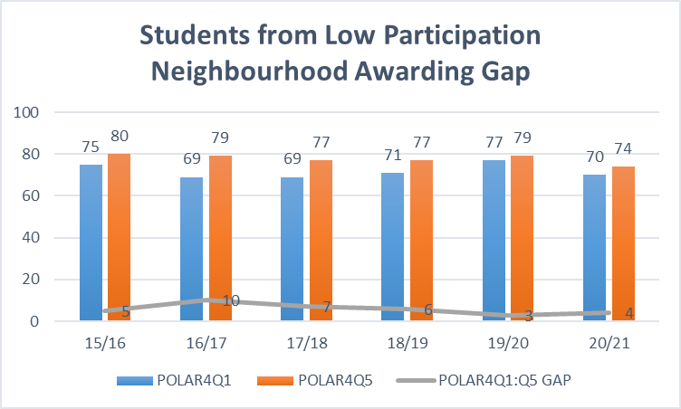

1.8 Disabled students
- The gap between disabled and non-disabled first-degree full-time students has narrowed from 8 percentage points to -1 percentage point in the last six years. This gap remains at -1 percentage point for students with cognitive and learning differences but has returned to 5 percentage points for students with mental health difficulties.
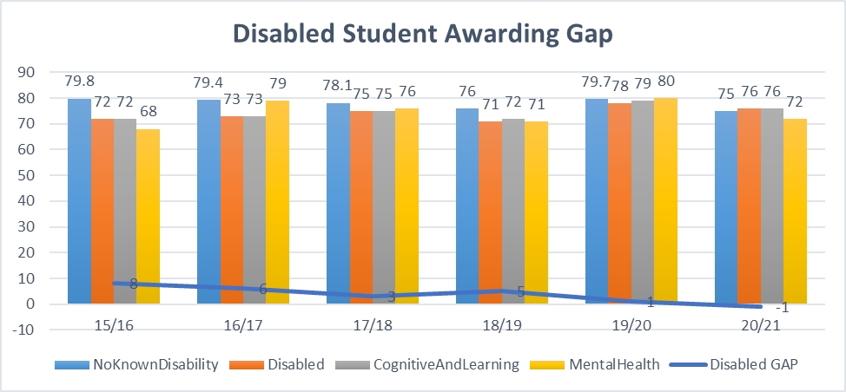

- Assessment and Marking Practices
- The university’s Assessment Regulations include assessment criteria which reference FHEQ standards at all levels up to and including Level 7.
- Level and Module learning outcomes are considered as part of the (re)validation process.
- Marking and moderation processes are described in the Assessment Regulations.
- External moderation is achieved via scrutiny of assessments by external examiners, marking criteria and associated processes and Progression and Award Board processes. External examiners are asked to confirm, inter alia, that academic standards and achievements are comparable to other higher education institutions and that internal marking 'is (in accordance with the University's policies and regulations) impartial, fair and consistent.'
- External examiner appointments must meet a range of criteria including subject expertise and assurances regarding conflicts of interest. In the rare cases where provision at a partner is not delivered in English, a UK based external examiner is appointed who is able to speak the language required and who is thus able to assure academic standards.
- The University participates in the AdvanceHE Degree Standards Project which focuses on the professional development of external examiners
- The University complies with all its PSRB reporting requirements. Where required there is PSRB representation on validation panels. Each validation and re-validation panel includes both an Academic and a ‘Professional’ external panel member.
- Regulations and Policies for Academic Appeals and Extenuating Circumstances both have set procedures for students to follow to request consideration of an appeal against the outcome of the Progression and Award Board or to request consideration of circumstances that have impacted on their studies.
- Appeals are managed by the central Quality Office thus ensuring consistency of approach and decision making. An annual report of the number and types of appeal is considered by Senate.
- Revised Extenuating Circumstances and Support to Study Procedures were introduced during 2021/22.

- Academic Governance
- Senate is responsible for 'exercising the power to award degrees and other awards to persons who complete an appropriate programme of study and satisfy an appropriate assessment as determined by Senate'. Authority is delegated to Progression and Award Boards which operate according to published regulations, procedures and guidelines.
- Collaborative partnerships operate within standard University governance. Marks from collaborative partners are scrutinised at a University of Winchester Progression and Award Board. The University's Assessment Regulations and Academic Regulations for Taught Programmes also apply to collaborative provision as do the University's External Examiners of Taught Programmes - Policy and Procedures.
- Senate Academic Development Committee receives an analysis of external examiner reports each year and an action plan arising out of feedback from external examiner reports including reports from external examiners at collaborative partners.
- The University established a Degree Outcomes Statement Standing Group in April 2021 which meets twice a year to consider trends in the university’s grade profile and monitor alignment of the university’s degree classification algorithm with sector guidance and practice. The group includes an external member from another university. The group has recently reviewed the impact of removing the upgrade rule in 2020-21 and the impact of the university’s no detriment policies during the Covid 19 pandemic. Actions arising from the group are considered by the relevant committee.
- The Board of Governors receives a report on degree outcomes each year.
- The completion of the University’s 2020 Degree Outcomes Statement involved external assistance as recommended by the Statement of Intent. This 2022 updated statement has been considered and approved by the university’s Executive Leadership Team, Senate and the University's Board of Governors.
- Classification Algorithms
- The University’s undergraduate algorithm is published in the University's Academic Regulations for Taught Programmes. Programme teams signpost students to the regulations.
- The algorithm emphasizes exit velocity by weighting the final level of the degree more highly and promotes the importance of the Extended Independent Study Module where this exists. It also permits students to mitigate for poor performance in some modules, whilst the exclusion of level 4 from the degree classification algorithm enables students to transition effectively into university study.
- Students are normally permitted automatic second attempts for all failed first attempts which are normally capped at the minimum pass mark. In exceptional circumstances a third attempt may be permitted.
- The University is discontinuing Grade Point Average (GPA) on its undergraduate programmes for students starting from September 2022. It was felt that GPA had the potential to confuse students and was not valued by employers.
- A Degree Differentials Task and Finish group met four times during 2017 and 2018 to consider the University’s grade profile and classification algorithm. Discussions also took place at Academic Regulations Policies and Procedures Committee and Senate Academic Development Committee.
- The task and finish group considered the impact of the regulations on degree classifications and modelled several different approaches. The group recommended the removal of the Upgrade Rule which was shown to result in inflation of the number of firsts and upper seconds awarded. The Upgrade Rule was removed for cohorts starting in September 2018 and for subsequent cohorts.
- During the 2019/20 and 2020/21 academic years, the University introduced No Detriment policies in response to the Covid 19 pandemic to ensure that students were not disadvantaged by the unprecedented circumstances. In 2021-22, the university has introduced a Covid Commitment to ensure that students’ final award calculation will not be impacted by the ongoing pandemic.
- Teaching Practices and Learning Resources
- The University seeks to maintain high quality learning and teaching across all its courses and provides a range of bespoke support, funding opportunities and prizes to encourage initiatives. A new Learning and Teaching Strategy is under development and will be one of the policies which underpin the University’s new Strategic Plan.
- Following on from the work of the Assessments Working Group during the 2021-22 academic year, the Assessment Regulations were updated in 2022 to incorporate changes to university-wide Assessment Criteria and Grade Descriptors. The revised criteria and descriptors
  - include Assessment Criteria and Grade Descriptors for Level 7 following a number of pilots;
  - take account of work around creativity and critical thinking in the international OECD project that Winchester has been involved in for several years;
  - are intended to be clearer for students;
  - incorporate an Academic English standard, to clarify how Winchester assesses English language proficiency.
- Assessment remains a key focus of every UG and PGT programme revalidation through inclusion of a mandatory 'Transforming the Experience of Students through Assessment' (TESTA) workshop.
- Assessment has also been given a greater focus in the new programme approval process which will launch in autumn 2022, through the completion of a mandatory toolkit on assessment and feedback. This enables reflection on a programmatic approach to effective assessment and feedback and includes examples of good practice.
- The department of Academic Quality and Development offers CPD for academic and professional services staff. In 2021/22 this has been extended to opening up modules on our MA in Learning and Teaching in Higher Education for staff across the university to take as CPD, on areas such as Inclusive Learning and Teaching and Decolonising the Curriculum.
- We have a sustained commitment to increasing the number of staff with HEA fellowship and based on current staffing, we have increased the percentage of full-time staff with fellowship from 56% in 2015-16 to 81.4% in 2020/21.
- Our Learning Management System, Canvas fulfils the W3C principles of digital accessibility and incorporates an immersive reader, keyboard navigation and an accessibility checker. We have purchased a 24/7 helpdesk service to support all users. We have also introduced evidence based and “patron-driven” models allowing students direct impact on the development of the library collection.
- We continue to review and enhance our mental wellbeing support, with a focus on both maintaining good mental wellbeing and supporting those who are experiencing mental health challenges. It is acknowledged that good mental wellbeing and a strong sense of belong intertwine to support the attainment of good academic outcomes. Thus, developing skills and confidence in mental wellbeing should result in positive degree outcomes for students.

- Identifying Good Practice and Actions

- We list below a few examples of good practice relating to classification at the University

- Annual reports to the Board of Governors about trends in degree classification
- The formation and work of the Degree Differentials Task and Finish Group in 2017-18
- The work of the Degree Outcomes Statement Standing Group in monitoring the university's grade profile and the impact of No Detriment measures during the Covid 19 pandemic.
- Annual update of the University’s Degree Outcomes Statement to include the most recent data
- A continued focus on and increasing numbers of academic staff obtaining HEA fellowship
- Participation in the AdvanceHE Degree Standards Project
- Review of and updates to the university assessment criteria and grade descriptors
- Removal of the Upgrade Rule
- The extension of TESTA workshops to postgraduate taught programmes from 2021-22.

- Risks and Challenges

- The development of a new Learning and Teaching Strategy which will have a genuine impact on practice, enhance the student experience and promote positive outcomes for students.
- The University continues to strive to reduce attainment gaps where these exist.
- The University is seeking to assess the impact of its teaching and learning enhancement initiatives on student attainment through a new approach to annual monitoring.
- Potential ongoing disruption caused by the Covid 19 pandemic.

Bachelor degree students, whose overall mark falls within 2% of the borderline for a higher honours classification and who have achieved a mark equivalent to the higher classification in at least 60 credits at level 6, shall have their degree classification upgraded. Integrated Master’s degree students, whose overall mark falls within 2% of the borderline for a higher honours classification and who have achieved a mark equivalent to the higher classification in at least 60 credits at level 7, shall have their degree classification upgraded.

